|  |  |
| --- | --- |
| E:\logos\Annamacharya Logo latest circle colour.jpg | **ANNAMACHARYA INSTITUTE OF TECHNOLOGY & SCIENCES**  **(Autonomous)**  (Approved by AICTE New Delhi & Permanent Affiliation to JNTUA, Ananthapuramu;  Three B.Tech programmes CSE, ECE & CE are accredited by National Board of Accreditation (NBA), New Delhi;  Accredited by NAAC, Bangalore; A-grade awarded by AP Knowledge Mission; Accredited by the Institution of Engineers IE(I), Kolkata; Recognized under sections 2(f) & 12 (B) of UGC Act 1956)  Venkatapuram (V), Karakambadi Road, Renigunta (M), Tirupati – 517 520. |

**DEPARTMENT OF COMPUTER SCIENCE AND ENGINEERING**

**CO Lab Programs for II CSE-2**

**1.**Implement **And** Gate using C Programming Language.

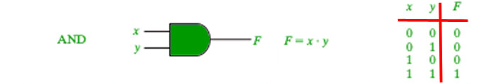

// C program implementing the AND gate

// through product method.

#include <stdio.h>

#include <stdlib.h>

int main()

{

int a[5] = { 1, 0, 1, 0, 1 };

int b[5] = { 0, 1, 1, 0, 0 };

int i, product;

for (i = 0; i < 5; i++) {

// using product method

product = a[i] * b[i];

printf("\n %d AND %d = %d", a[i], b[i], product);

}

}

**Output:**

1 AND 0 = 0

0 AND 1 = 0

1 AND 1 = 1

0 AND 0 = 0

1 AND 0 = 0

**2.**Implement **OR** Gate using C Programming Language

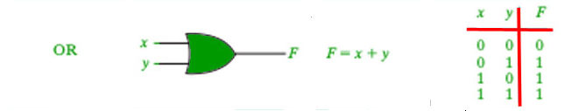

// C program implementing the OR gate

// using + operator

#include <stdio.h>

#include <stdlib.h>

int main()

{

int a[5] = { 1, 0, 1, 0, 1 };

int b[5] = { 0, 1, 1, 0, 0 };

int i, or_ans;

for (i = 0; i < 5; i++) {

// using the + operator

if (a[i] + b[i] > 0)

or_ans = 1;

else

or_ans = 0;

printf("\n %d AND %d = %d",a[i], b[i], or_ans);

}

}

**Output:**

1 AND 0 = 1

0 AND 1 = 1

1 AND 1 = 1

0 AND 0 = 0

1 AND 0 = 1

**3.**Implement **Nand** Gate using C Programming Language

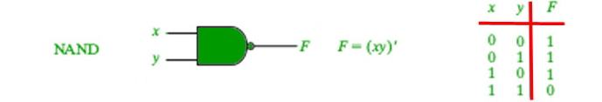

// C program implementing the NAND gate

#include <stdio.h>

#include <stdlib.h>

int main()

{

int a[5] = { 1, 0, 1, 0, 1 };

int b[5] = { 0, 1, 1, 0, 0 };

int i, ans;

for (i = 0; i < 5; i++) {

if (a[i] == 1 && b[i] == 1)

ans = 0;

else

ans = 1;

printf("\n %d NAND %d = %d",a[i], b[i], ans);

}

}

**Output:**

1 NAND 0 = 1

0 NAND 1 = 1

1 NAND 1 = 0

0 NAND 0 = 1

1 NAND 0 = 1

**4.**Implement **Nor** Gate using C Programming Language

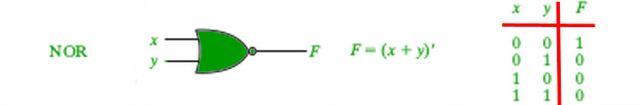

// C program implementing the NOR gate

#include <stdio.h>

#include <stdlib.h>

int main()

{

int a[5] = { 1, 0, 1, 0, 1 };

int b[5] = { 0, 1, 1, 0, 0 };

int i, ans;

for (i = 0; i < 5; i++) {

ans = !(a[i] + b[i]);

printf("\n %d NOR %d = %d",a[i], b[i], ans);

}

}

**Output:**

1 NOR 0 = 0

0 NOR 1 = 0

1 NOR 1 = 0

0 NOR 0 = 1

1 NOR 0 = 0

5.Implement **Not** Gate using C Programming Language

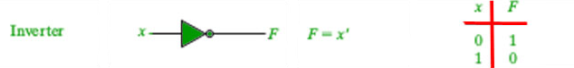

// C program implementing the NOT gate

#include <stdio.h>

#include <stdlib.h>

int main()

{

int a[5] = { 1, 0, 1, 0, 1 };

int i, ans;

for (i = 0; i < 5; i++) {

if (a[i] == 0)

ans = 1;

else

ans = 0;

printf("\n NOT %d = %d", a[i], ans);

}

}

**Output:**

NOT 1 = 0

NOT 0 = 1

NOT 1 = 0

NOT 0 = 1

NOT 1 = 0

**6.**Write a C Program to convert Decimal Number to Binary Number

#include <stdio.h>

int main() {

int decimal_num, binary_num = 0, i = 1, remainder;

printf("Enter a decimal number: ");

scanf("%d", &decimal_num);

while (decimal_num != 0) {

remainder = decimal_num % 2;

decimal_num /= 2;

binary_num += remainder * i;

i *= 10;

}

printf("Binary number: %d\n", binary_num);

return 0;

}

**Output:**

Enter a decimal number: 5

Binary number: 101

**7.**Write a C Program to convert binary number to Decimal Number.

#include <stdio.h>

#include <math.h>

int main()

{

int i, bin_num, decimal_num = 0, rem;

printf("Enter Binary Number");

scanf("%d",&bin_num);

for (i = 0; bin_num != 0; ++i)

{

rem = bin_num % 10;

bin_num = bin_num / 10;

decimal_num = decimal_num + (rem) * ( pow (2, i));

}

printf ("\n Decimal Number of given binary number: %d", decimal_num);

return 0;

}

**Output:**

Enter Binary Number111

Decimal Number of given binary number: 7

**8.**Write a C Program to convert Binary to Hexadecimal Number.

#include <stdio.h>

int main()

{

long int binarynum, hexadecimalnum = 0, i = 1, rem;

printf("Enter a Binary number: ");

scanf("%ld", &binarynum);

while (binarynum != 0)

{

rem = binarynum % 10;

hexadecimalnum = hexadecimalnum + rem * i;

i = i * 2;

binarynum = binarynum / 10;

}

printf("Equivalent Hexadecimal number: %lX", hexadecimalnum);

return 0;

}

**Output:**

Enter a Binary number: 10001101

Equivalent Hexadecimal number: 8D

9.Write a C Program to convert binary to octal Number

#include <stdio.h>

int main()

{

long int binary, octal=0;

int j, remainder;

j = 1;

octal = 0;

printf("Enter Binary number");

scanf("%ld",&binary);

while(binary!=0)

{

remainder = binary % 10;

octal = octal + remainder * j;

j = j * 2;

binary = binary / 10;

}

printf("Octal = %lo\n", octal);

return 0;

}

**Output:**

Enter Binary number111100

Octal = 74